PROMISE & PRACTICE · DEEP DIVE · SOURCE ANALYSIS
The 15th Amendment — A House Divided
The Vote — and Its Limits
Name: ______________________________ Period: _____ Date: ________________
WHAT I CAN DO TODAY I can read primary sources about The 15th Amendment — A House Divided, weigh who made each one and why, and use evidence to answer historical questions.
Directions. A right extended to some raises a hard question about the rest. Read the perspectives and judge

THE SOURCES
SOURCE · THE 15TH AMENDMENT · 1870 — The text
“The right of citizens of the United States to vote shall not be denied or abridged … on account of race, color, or previous condition of servitude.”
— U.S. Constitution, Amendment XV. Public domain
— U.S. Constitution, Amendment XV. Public domain.
THE IMAGE · 1867 — “The First Vote”
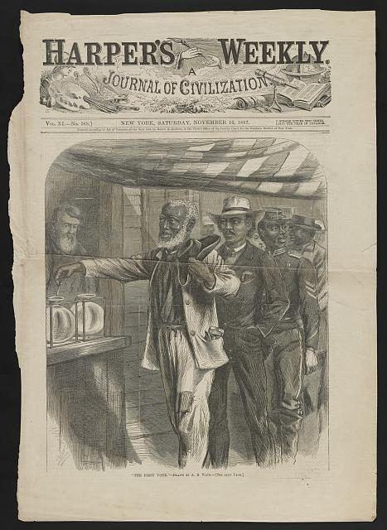
“The First Vote” — wood engraving by Alfred R. Waud, Harper's Weekly, 1867, public domain (Library of Congress).

YOUR WORK
QUESTION 1 STEP 1 · WHO GAINED
Look at “The First Vote.” Who are the men in line (notice their clothing and roles), and what is the artist saying about the new Black electorate?
____________________________________________________________________________________________
____________________________________________________________________________________________
____________________________________________________________________________________________
QUESTION 2 STEP 2 · WHO WAS LEFT OUT
The amendment bars denying the vote by “race, color, or previous condition of servitude.” Who did it still leave unable to vote?
☐ A. no one — everyone could vote
☐ B. only former Confederates
☐ C. women of every race
☐ D. men who had served in the army
QUESTION 3 STEP 3 · TWO POINTS OF VIEW
Some women's-rights leaders felt betrayed that Black men got the vote before any women. Douglass argued Black men's vote was “life and death” and couldn't wait. Explain both points of view fairly.
____________________________________________________________________________________________
____________________________________________________________________________________________
____________________________________________________________________________________________
____________________________________________________________________________________________
QUESTION 4 STEP 4 · THE LOOPHOLE
The amendment banned denying the vote “on account of race” — but not other excuses. In three or four sentences, explain how Southern states later used poll taxes and literacy tests to get around it, and why the wording made that possible.
____________________________________________________________________________________________
____________________________________________________________________________________________
____________________________________________________________________________________________
____________________________________________________________________________________________
____________________________________________________________________________________________
Promise & Practice · ShadowDog Digital Studios · Unit 2

TEACHER ANSWER KEY — The 15th Amendment — A House Divided

QUESTION 1: Open response.
Look for a response along the lines of: “The men include…; the artist is saying…”
QUESTION 2: Correct — C. women of every race
Right. The amendment said nothing about sex — so women of every race were still denied the vote, a gap that split the reform movement and took 50 more years to close.
QUESTION 3: Open response.
Look for a response along the lines of: “The women's-rights leaders felt…; Douglass argued…”
QUESTION 4: Open response.
Look for a response along the lines of: “Because the amendment only banned race-based denial, states could…”

